**CS 214 Database Technologies – SQL and NoSQL**

**PE10 - NoSQL Queries – and operator and comparison operators**

Center for Information Assurance (CIAE) @City University of Seattle (CityU)

7/6/2020 Developed by Clark Ngo



**Before You Start**

* If you have questions about the lab requirements, please ask a TA to clarify for you.
* If you are not sure what to do:
  1. Consult the resources listed below.
  2. If you cannot solve the problem after a few tries, ask a TA for help.

**Lab Tasks**

* Write NoSQL queries to complete the given tasks

Write a MongoDB query to find the restaurants which locate in a latitude value less than -95.754168.

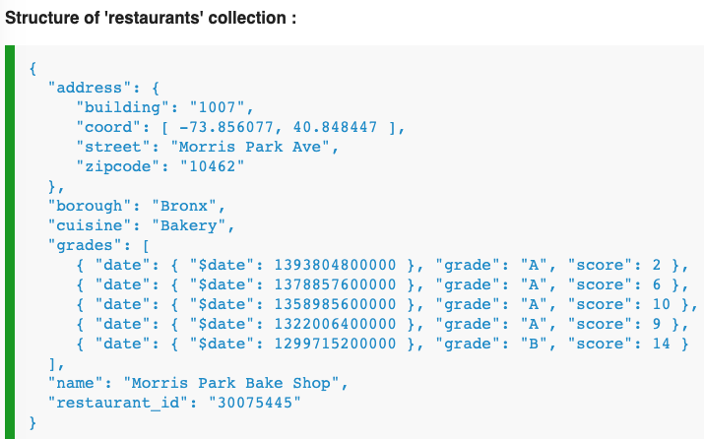

Research here: <https://docs.mongodb.com/manual/crud/>

Query:

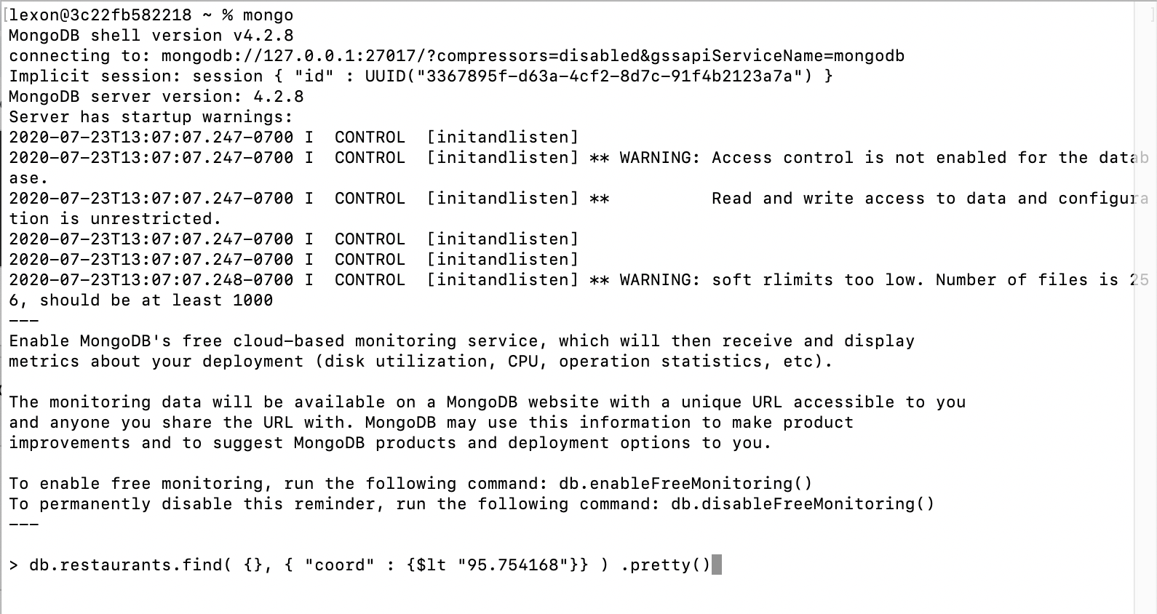

Write a MongoDB query to find the restaurants that do not prepare any cuisine of 'American' and their grade score more than 70 and lattitude less than -65.754168.



Research here: <https://docs.mongodb.com/manual/crud/>

Query: 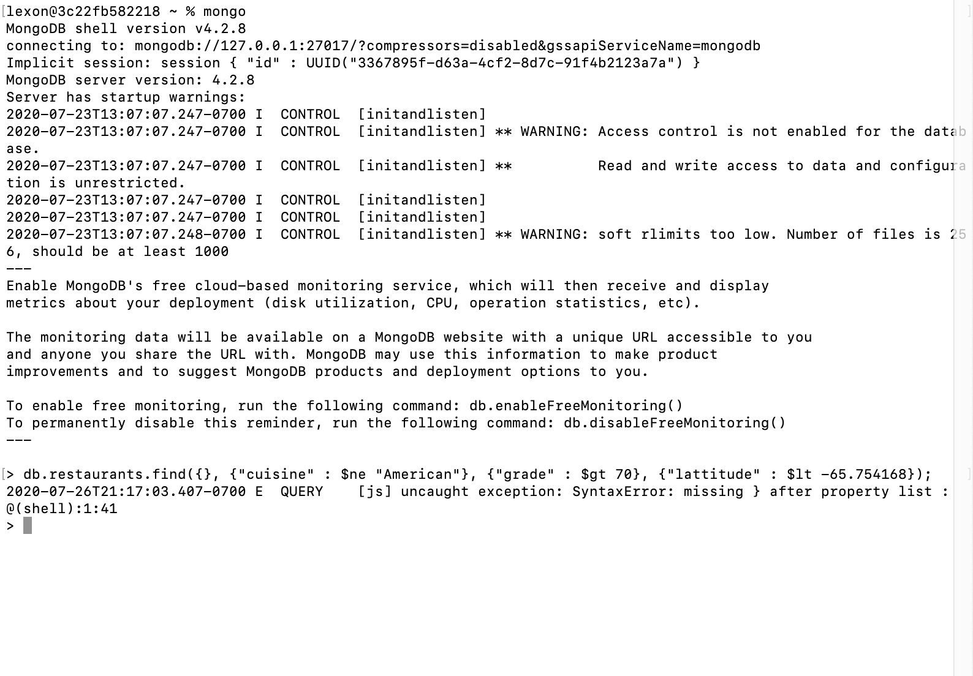

Write a MongoDB query to find the restaurants which do not prepare any cuisine of American and achieved a score more than 70 and located in the longitude less than -65.754168.  
Note : Do this query without using $and operator.



Research here: <https://docs.mongodb.com/manual/crud/>

Query: 